**Dataset:** VerSe: Large Scale Vertebrae Segmentation

<https://github.com/anjany/verse>

**Task:**

Label and Segment the bones from CT scan images.

There are 33 vertebral columns in human body. Using the given image, first you have to identify the bones then localize the columns and segments them.

Finally label the columns either with different color or by a single character label.

To label, you should perform recognition of the column using its features. Example is given below.

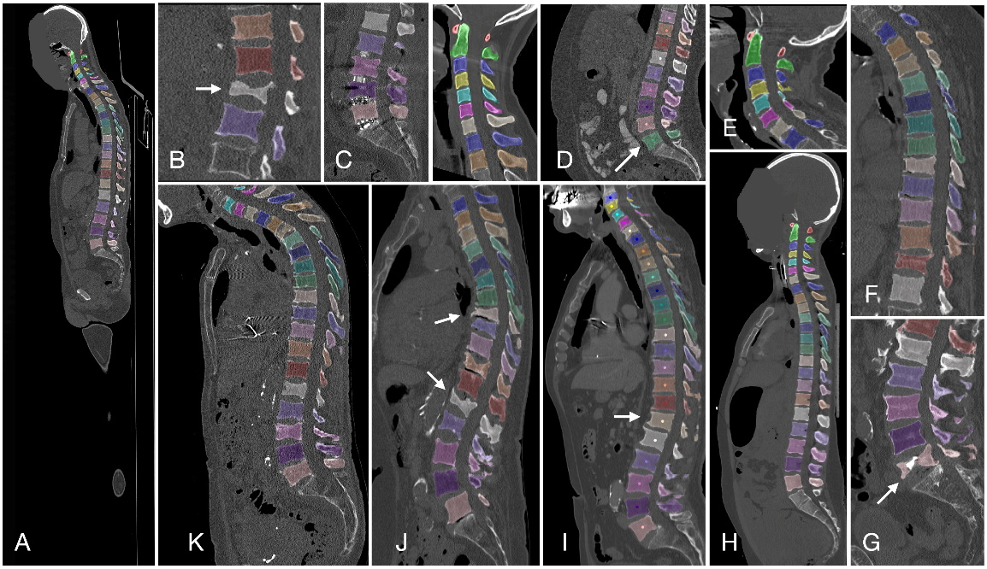

**Performance metrics**

1. Labelling accuracy
2. F-measure based metrics like Dice Similarity Coefficient (DSC) and Intersection-over-Union (IoU)
3. Sensitivity (Sens) and Specificity (Spec)
4. Accuracy / Rand Index (Acc)
5. Receiver Operating Characteristic (ROC) and the area under the ROC curve (AUC)
6. Cohen’s Kappa (Kap)
7. Average Hausdorff Distance (AHD)